Baseline Characteristics Experiment

Purpose
State the objective of determining dead band, minimum controllable speed, and maximum achievable speed under open-loop actuation.

Method
Describe:
• Ramp input pattern
• Measurement variables
• Sampling period and logging configuration
• Test conditions

Conduct
Use ramp up input function:

Results Storage
(Include three repeated trials)
Trial 1 …………………………………………
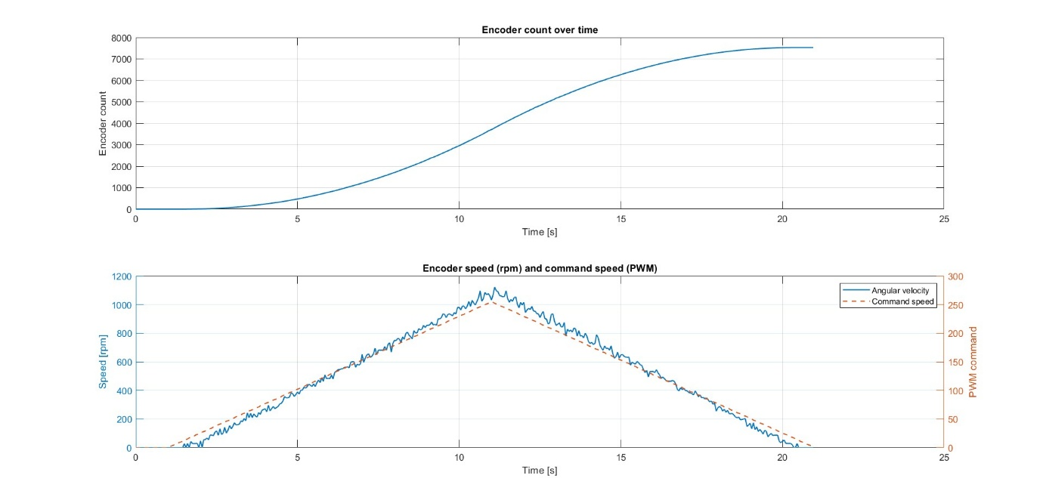
MATLAB’s Command window
=== MOTOR BASELINE (START / STOP) ===
Motor START : t = 1.500 s, PWM = 13.0
Motor STOP : t = 20.451 s, PWM = 14.0

Trial 2 …………………………………………
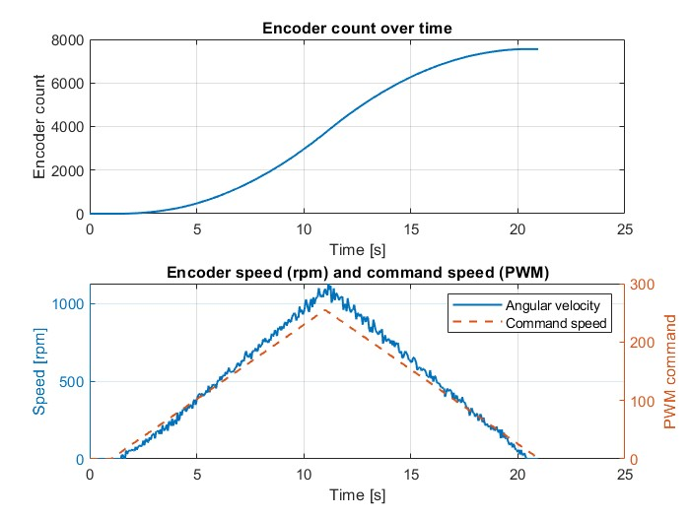
=== MOTOR BASELINE (START / STOP) ===
Motor START : t = 1.501 s, PWM = 13.0
Motor STOP : t = 20.351 s, PWM = 17.0

Trial 3 …………………………………………
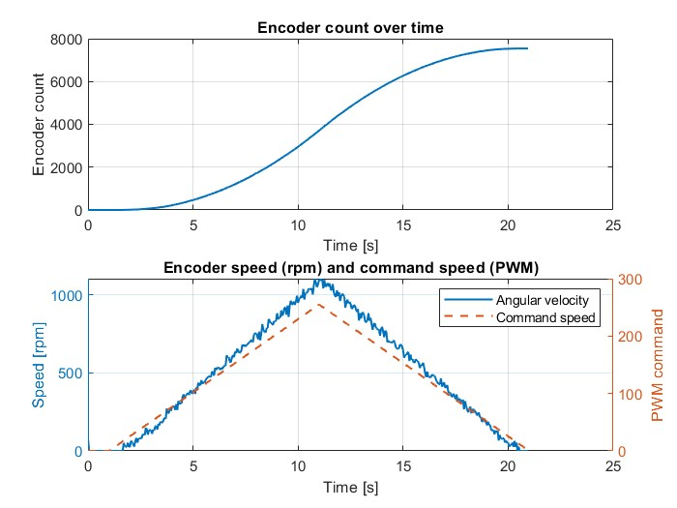
=== MOTOR BASELINE (START / STOP) ===
Motor START : t = 1.700 s, PWM = 18.0
Motor STOP : t = 20.500 s, PWM = 13.0

Trial …………………………………………
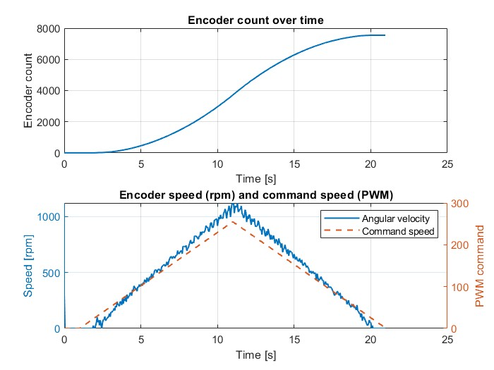

Summary of extracted parameters
Dùng deadband cỡ 40

Step-Input Noise and Filtering Evaluation

Purpose
Characterize noise/outliers and determine optimal filtering parameters (N, M).

Method
Describe step inputs, encoder sampling, MATLAB processing, filtering methods.

Conduct
Execution sequence and repeated trials.

Results Storage
Trial 1 …
Trial 2 …
Trial 3 …
Window parameter selection

Steering-Angle Influence Experiment

Purpose
Evaluate whether Ackermann steering angle affects motor speed/load.

Method
Fixed duty levels, varying steering angles, sampling method.

Experimental Design (optional DoE)
Factors, levels, response.
Experimental matrix template.

Conduct
Execution according to the matrix, three repetitions per condition.

Results Storage
Condition blocks (each with Trial 1–3).
Summary table.

System Identification Experiment

Purpose
Obtain transfer function or state-space model of the motor (outside deadband).

Method
Random step/ramp input design, data acquisition, MATLAB identification.

Conduct
Trial execution, separation of training and validation sets.

Results Storage
Training trials 1–3.
Model validation section.
Final chosen model.

Controller Design Record (Non-experimental)
(This is not an experiment)’

Purpose
State the objective of designing the controller (speed loop and/or position loop).

Method
Describe:
• Model used for design
• Design approach (PID, PI, state-feedback, etc.)
• Stability and performance criteria
• Parameter tuning procedure

Controller Parameters
Space to record final chosen gains and justification.

Notes
Assumptions, limitations, constraints.

Controller Verification Experiment

Purpose
Validate controller performance under step, ramp, and motion-profile references.

Method
Reference profiles, feedback signals, logging configuration.

Conduct
Execution sequence, reset conditions, repeated trials.
6.4 Results Storage
Step tracking trials 1–3.
Ramp tracking trials 1–3.
Motion profile trials 1–3.
Final summary
Performance, limitations, redesign notes.

